MOTOR PART NR |  | OH090S4 | CUSTOMER PART NR
DRAWING NR |  | OH090S4 | MOTOR TYPE |  |  | OH090S A4
Type of winding |  | 3 PHASE 1 SPEED 6 LEADS |  | EFFICIENCY IE | IE3 |  | 4/4 |  | 3/4 | 1/2
 |  |  |  |  |  |  | 84,1 |  | 84,1 | 81,6
PROTECTION | II 2G Ex db IIC T4 Gb |  | CERTIFICATE |  | EPT 17 ATEX 2588X
IP PROTECTION |  | IP66 | ENVIRONMENT CONDITIONS |  |  | -20 /+50°C Max Altitude: 1000m
POLES |  | 4 | NOMINAL POWER kW |  |  | 1,10
Nom. Speed rpm |  | 1440  1735 | Voltage-Frequency |  |  | 230/400V 50Hz  265/460V 60Hz |  | Tolerance: Voltage ±5%
Nom. Current A |  | 4,52/2,61  4,52/2,61 | COS φ |  |  | 0,724  0,724
Starting current / Rated current |  | 6,6 | Starting torque /  Rated torque |  |  | 2,8
Breakdown torque/ Rated torque |  | 2,8 | Weight |  |  | 16
Duty |  | S1 Continuous Duty | Direction of Rotation |  |  | BIDIRECTIONAL
Insulation Class |  | F | Mounting IM |  |  | B3
IEC Frame Size |  | 90 | Material end Shield/Flange |  |  | Aluminium
Material Terminal Box |  | Aluminium | Material Fan |  |  | Plastic
Material Cover Fan |  | Zinc plated steel | Material shaft |  |  | Steel C43
DE Bearing Type |  | 6205-ZZ | NDE Bearing Type |  |  | 6205-ZZ
Position of terminal box |  | TOP | Cable gland Type |  |  | M20x1,5
Cable gland position (view from DE) |  | Right | Thermal protection
Painting |  |  | Motor Colour

In compliance with the EC Directives | and comply with the following Standards
2014/34/UE (ATEX)  2014/30/UE (EMC)  2006/42/EC (Machinery)  2011/65/CE (RoHS II) | EN 60079-0,  EN 60079-1, 31  EN 60034-1,2,5,6,7,9,12,14,  IEC60072-1,  EN 60259
Overall dimensions (mm)
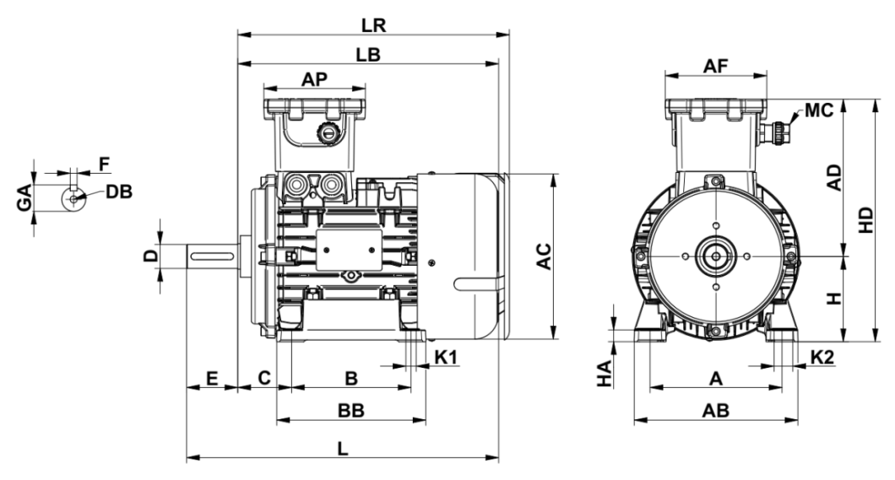

B | A | HA | BB | AB | AC | AD | AP | AF | C | H | HD | LB | LR | L | K1 | K2 | MC | D | E | GA | F | DB
100 | 140 | 14,5 | 130 | 170 | 176 | 174 | 119 | 119 | 57 | 90 | 264 | 270 | 283 | 320 | 10 | 17,5 | M20 | 24 | 50 | 27 | 8 | M8X19

