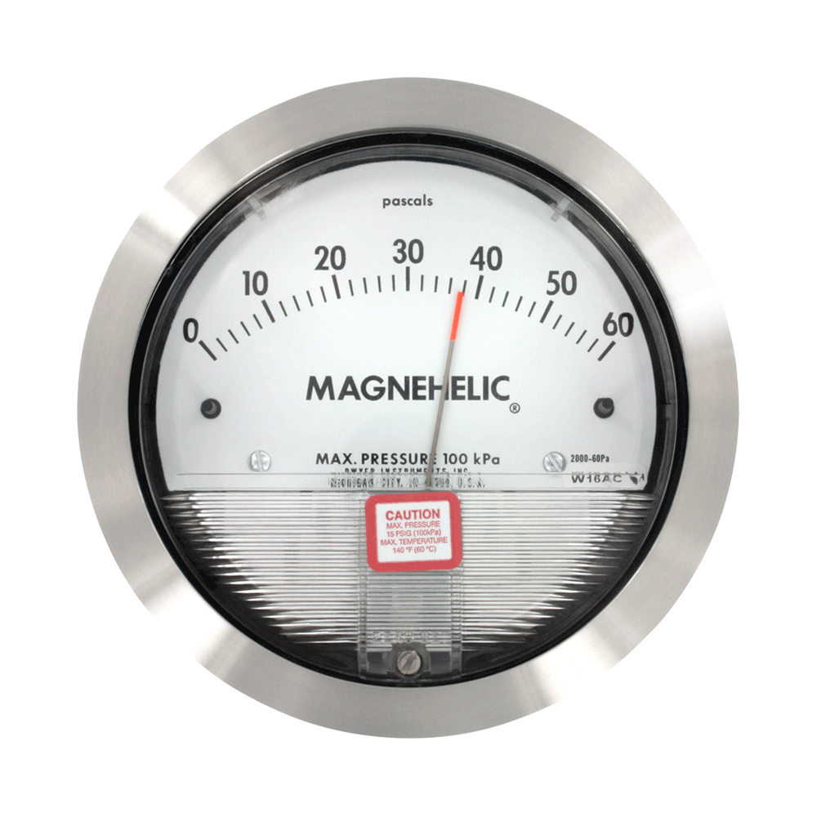

Dwyer Magnehelic Series 2000 (Model 2000-60PA)

