ITEM | PART NUMBER | Detailed Product Description | Unit of measurement | Quantity
1 | ---- | PORTABLE COLLECTOR EQUIPMENT TO MEASURE SHOCK IMPULSE & QUICK ANALYZER OF CONDITION OF CONDITION OF BEARINGS; SIMILAR OR TECHNALLY EQUIVALENT TO: PRUFTECHNIK VIB 8.820 VIBROTIP EX | EA | 1

2.1.1. General characteristics

ITEM 1. PORTABLE COLLECTOR EQUIPMENT FOR MEASURING SHOCK IMPULSE

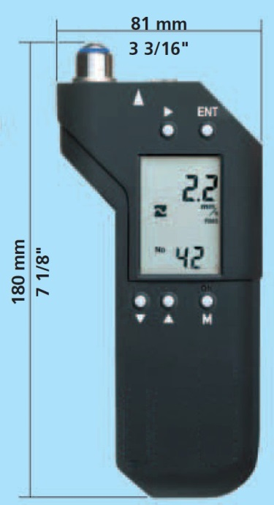

Application
• Portable vibration data collector for rapid measurement of the condition of the bearing condition using the shock impulse method (SPM).

Analysis functions
• Measurement of vibration intensity.
• Measurement of the state of bearings using shock pulse method.
• Measurement capacity over 1000 measurements.

Hardware
• Sensor built into the instrument without cables or delicate connections.
• Internal memory card.
• Impact resistant housing, chemicals, dust and water (IP65).
• Intrinsically safe version for work in CLASS I zones DIVISION II GROUP C, D.

Ergonomics
• LCD Display & Dimensions for single-handed use.

Energy
• Auto power off.
• Energized with rechargeable battery with duration of at least 3 hours.
• Equipment charger without battery disassembly.

Communication
• Connection to PC via USB.
• PC license.

2.1.2. List of components

1. Intrinsically safe multimeter with the following measurement modes:
• Vibration
• Shock Pulse bearings
2. Carrying case for belt instrument.
3. Instrument case.
4. Instruction manual for operation of the instrument in physical and digital format.
5. Documentation in digital format of condition monitoring.
6. Battery.

2.1.3. Technical characteristics.

Technical data

Vibration
- Built-in sensor.
- Units of measurement: mm / s, in / s (selectable).
- RMS peak-to-peak 0-peak
- Frequency range: 10 Hz - 1 kHz.
- Measuring range 0-50 mm / s / 0-2in./s RMS
- The maximum value depends on the sensor and the signal frequency.
- Resolution 0.1 mm / s, 0.01 in./s
- Accuracy + 5% (DIN 45666)

Bearing diagnostics
- Built-in sensor.
- Units of measurement dBSV, dBN, valley value, peak value.
- Range -9 - 80 dBSV.
- Resolution 1 dBSV.

Data collector
- Measurement capacity over 1000 measurements without trend software, including date and time for each point.
- Routes with programming of up to 1000 measurement points.

General characteristics
- Interface: RS-232C (9600Baud).
- I work with 1 battery.
- LCD screen (5x10 mm digits).
- Protection IP 65 (waterproof and dustproof).
- chemical protection.
- Temperature range 0-60 ° C (32-140 ° F).
- Auto power off.
- Shock resistance tested from 2m (6ft.).
- Approximate dimensions: high 180 [mm], width 81 [mm], thickness 32 [mm].
- Approximate weight included battery 300g (10 oz.)

